MSSQL HR Analytics Report
1) Total No of Employees
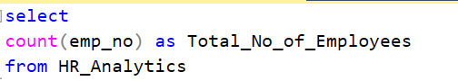
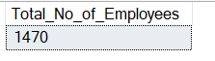
2) Total no of Attrition
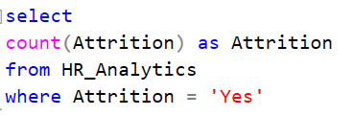
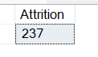
3) Attrition Rate
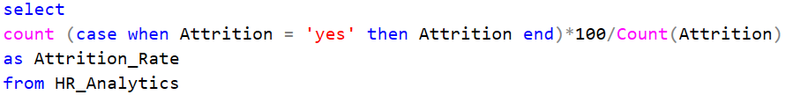
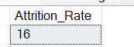
4) Active Employees
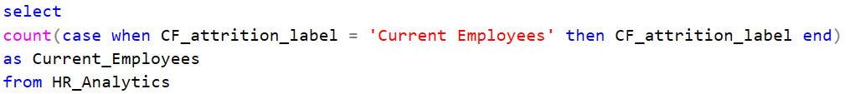
Or
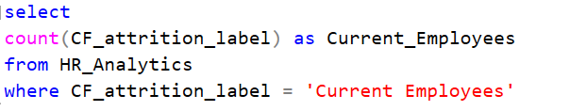
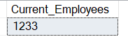
5) Average Age
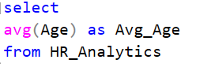
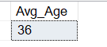
6) Field wise total no. of Employees
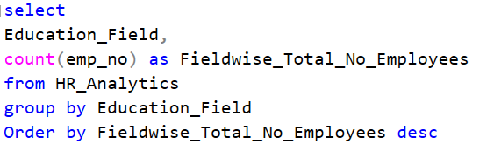
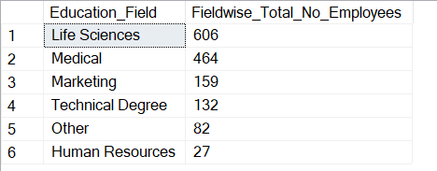
7) Field wise Attrition
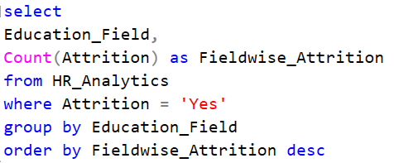
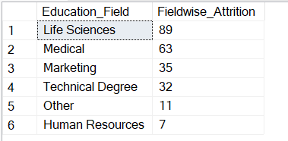
8) Department wise Total No. of Employees
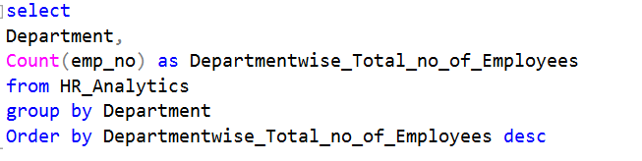
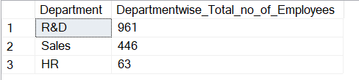
9) Department wise Attrition
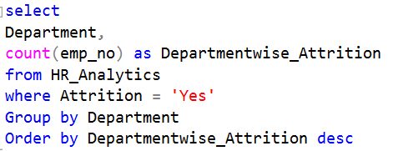
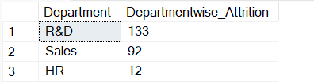
10) Age group wise Total No. of Employees
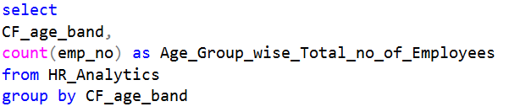
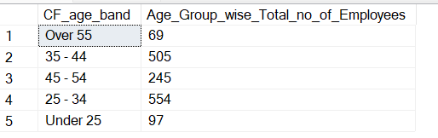
11) Job Role wise total no of Employees
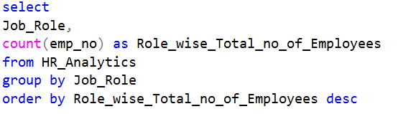
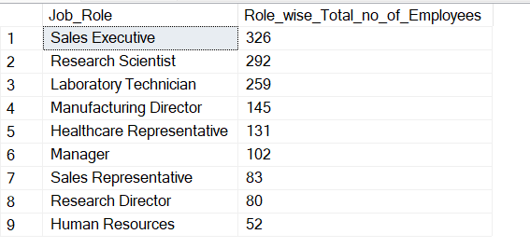
12) Total No of Male Employees for different Job Role
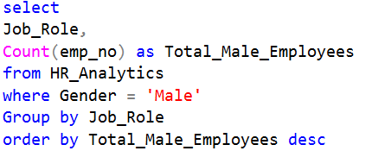
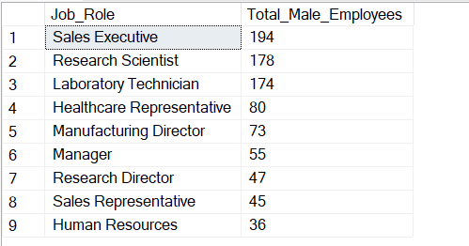
13) Total No of Female Employees for different Job Role
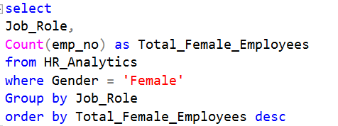
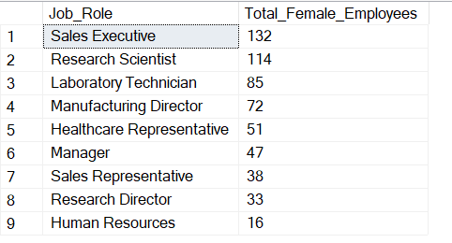
14) Attrition by Job Role
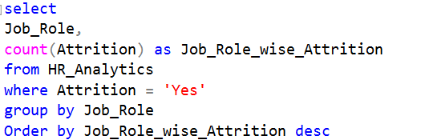
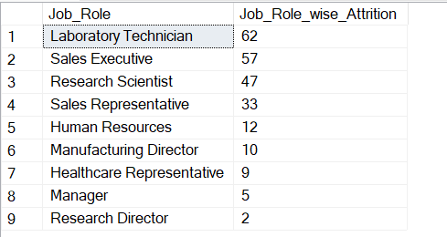
15) Age Group wise Attrition
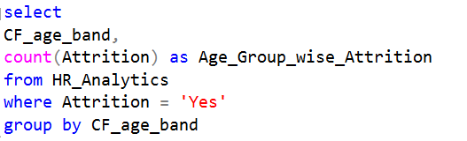
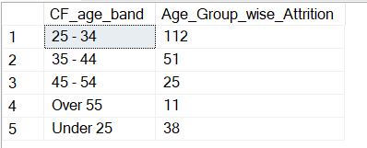
16) Attrition by Gender
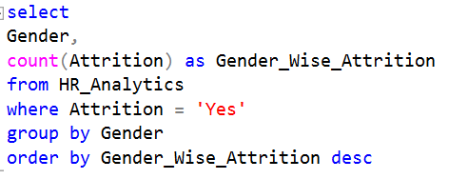
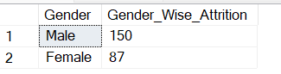
17) Attrition by Gender for different Age Group
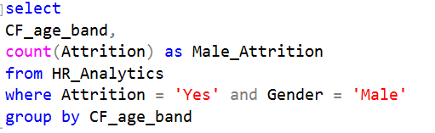
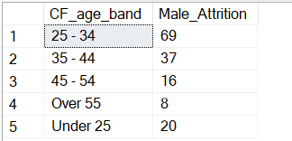

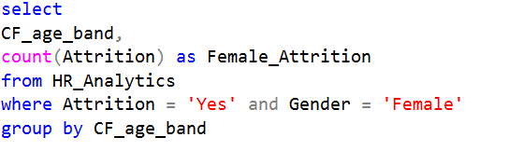
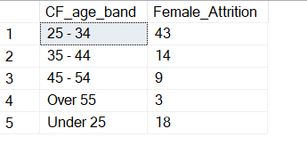
18) Attrition Rate by Gender
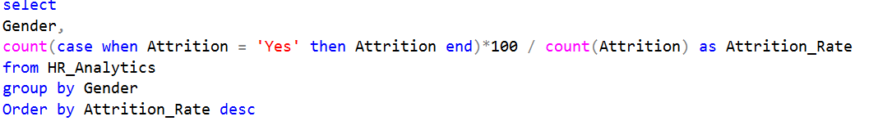
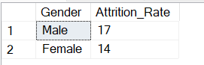
19) Attrition Rate by Age Group
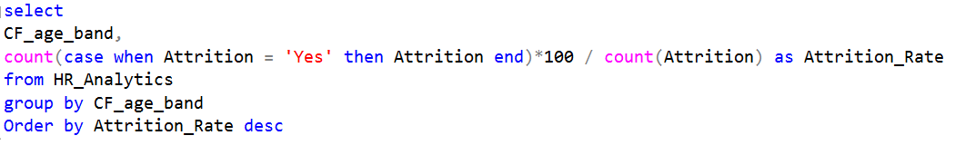
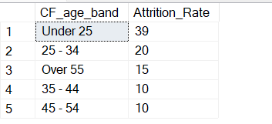
20) Department wise Highest Job Satisfaction Rating
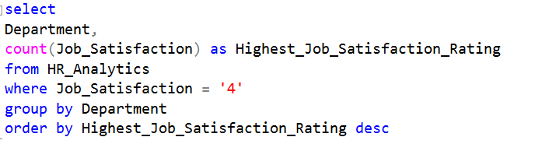
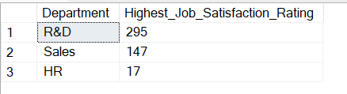
21) Department wise Lowest Job Satisfaction Rating
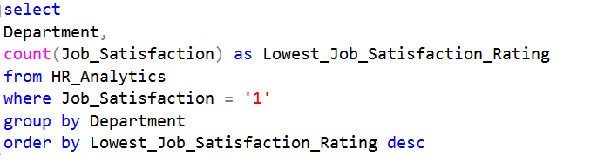
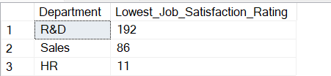
22) Field wise Highest Job Satisfaction Rating
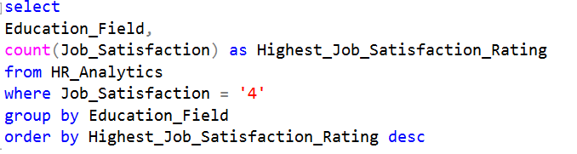
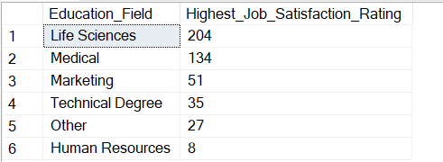
23) Field wise Lowest Job Satisfaction Rating
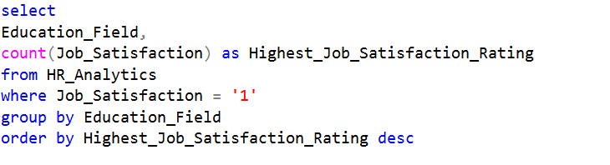
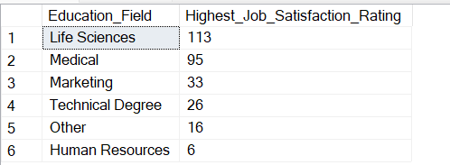
24) Job Role wise total no of Employees doing over time
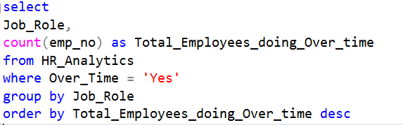
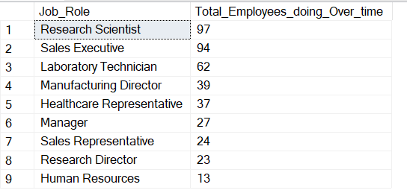
25) Job Role wise total no. Employees whose Performance Rating is High
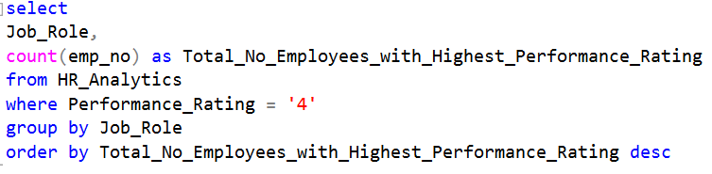
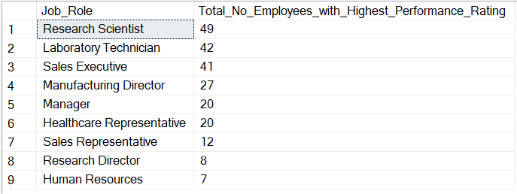
26) Job Role wise total no. Employees whose Performance Rating is Low
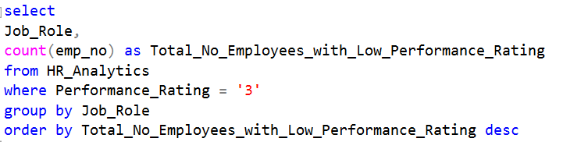
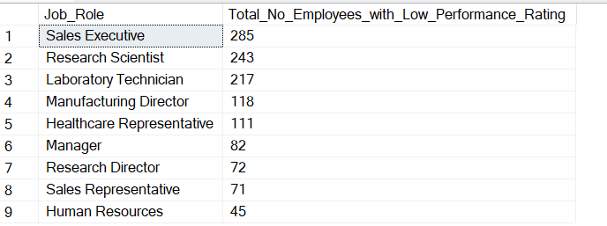
27) Job role wise total no of Employees whose Salary Hike more than 15%
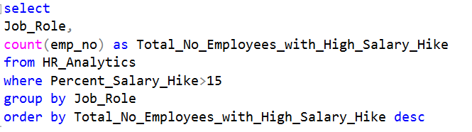
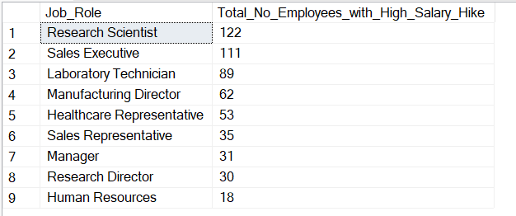
28) Job Role wise total no Employees who worked earlier in more companies
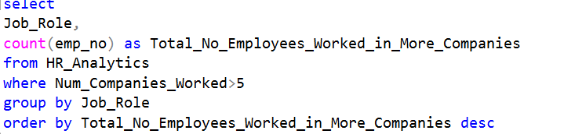
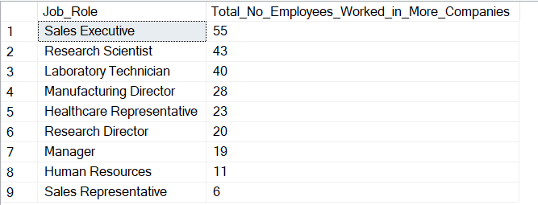
29) Job Role wise total no of Employees who worked in current role for more than 5 Years
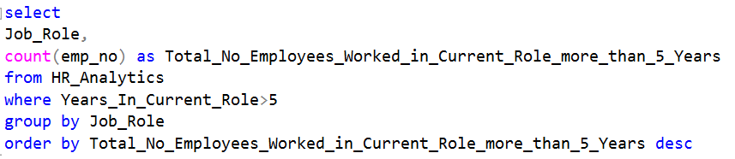
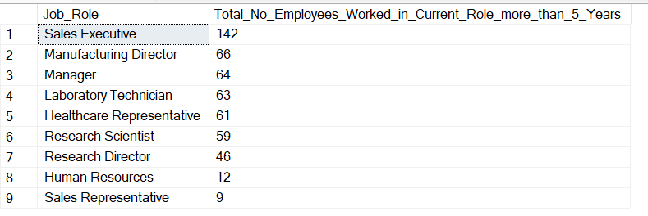
30) Department wise total no of Employees whose Performance Rating is High
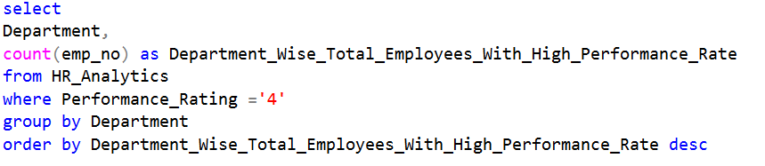
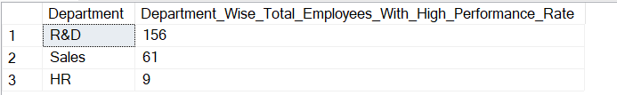
31) Department wise total no of Employees whose Performance Rating is Low
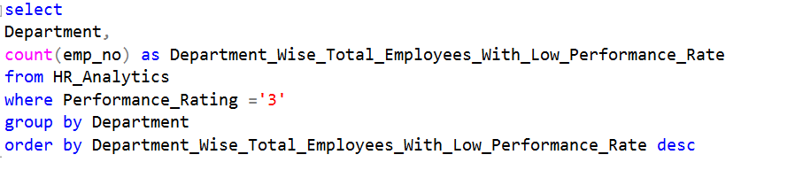
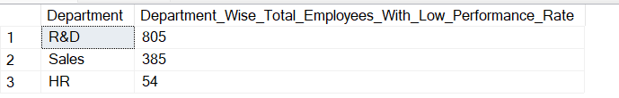
32) Department wise total no of Employees who worked in current role for more than 5 Years
